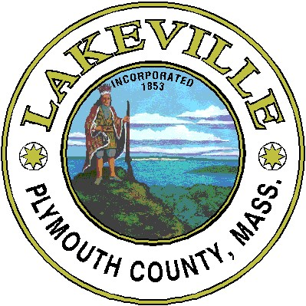

Lakeville Board of Health Regulations Pertaining to Dogs and Outdoor Dining.

Restaurant owners who choose to allow dogs in outdoor dining must abide by the requirements below.

Restaurants shall have the right to refuse any dog that is not a service animal from their restaurant.
Dogs are not allowed indoors or anywhere food is prepared, not even to walk through to outdoor area.
The restaurant shall have the right to refuse to serve the owner of a pet dog if the owner fails to exercise reasonable control over the pet dog or the pet dog is otherwise behaving in a manner that compromises or threatens to compromise the health or safety of any person present in the restaurant.
Owner is responsible for the behavior of that dog, and the dog must also be on a leash or in a pet carrier.
Restaurant employees are prohibited from petting or playing with any dogs.

Dogs are not allowed to eat or drink using the restaurant's glasses, plates, utensils, tableware, linens or any other items involved in food service operations. Dog owners should bring their dog a disposable water bowl.
All dogs have to stay on the ground.
Area for dogs must be identified with a sign posted at all entrances to outdoor area. Signs are not required at restaurants that choose not to allow pet dogs in outside dining areas.
All dogs must be licensed and vaccinated against rabies.
Restaurants must develop plans to handle dogs and their waste. Accidents involving pet dog waste shall be cleaned immediately and the area sanitized with an approved product, by restaurant workers who do not prepare or serve food. A kit with the appropriate materials for this purpose shall be kept near the designated outdoor area.

All restaurants that wish to allow dogs in outdoor dining areas must notify the Lakeville Board of Health to do an inspection of the dog area prior to allowing dogs at the outdoor dining areas of the restaurant.

